NAME: _____________________ DATE: April 4th, 2016
SUBJECT: English Language Arts_ CLASS: Hamilton Syracuse
Word Work

DO use verbs like “encounter” or “face” before the word “adversity” when describing the action of coming up against a challenge. | Example: The team expects to encounter adversity if their star player is still out injured.

- Circle the preposition needed to complete the sentence.
The woman overcomes financial adversity _______ working two jobs for ten years.
  - by
  - of
  - to
  - No preposition needed.

GO ON>
- Prosperity means the state of being successful, usually by making a lot of money. Read the following moral of one of Aesop’s fables.
We must make friends in prosperity if we would have their help in adversity.

To which of the following stories would this moral apply?
  - A family of birds who cannot find food work together until one day they discover an area with more worms than they could ever eat and never go hungry again.
  - A young queen bee befriends many of her servant bees. She is a kind queen and shares her wealth with them. When one day, she suffers a broken wing, her servants come to her aid rather than replace her with a new queen.
  - A duckling who is cold in the night is welcomed into a manger by a barn dog. The duckling cuddles with the barn dog through the night to become warm. In the morning, when the duckling awakes, the barn dog has gone.
  - A caterpillar wants so badly to be a butterfly, that he tries his best to follow butterflies around all day. They are usually too fast for him, but one butterfly always flies a little bit slower to allow the caterpillar to catch a glimpse. When the caterpillar finally turns into a butterfly, he finds the kind butterfly to say thank you for always slowing down.

GO ON>
Vocabulary Review
Directions: Write a sentence using each of the words below to describe the image given
 | - insinuate
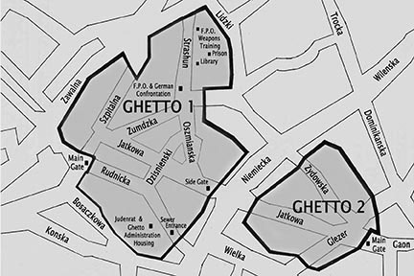 | - ghetto
 | - genre

GO ON>
Strategy Practice
Directions: Read the articles and use the following test-taking strategies to answer the questions that follow.
- Annotate the question.
- Use process of elimination.
- Annotate the answer choices
- Reread section of the text that seem hard to understand and write a chunking main idea sentence for that paragraph.

Nobel laureate Malala, Afghan novelist show how to wield power with words
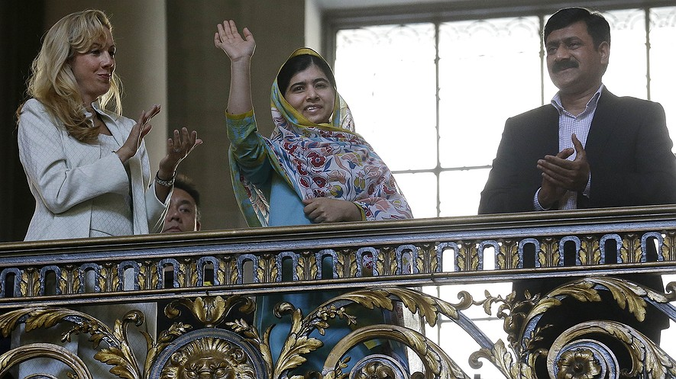
When the world’s youngest Nobel Peace Prize winner walked onstage June 26 at San Jose State University to a standing ovation, the first words she said to the roaring crowd were “Thank you.” A 4,000-strong audience of young and old had gathered to hear from 17-year-old Malala Yousafzai. Girls held her book, “I Am Malala” and parents whispered her story into the ears of their children.
GO ON>
In his introduction, Afghan-American novelist Khaled Hosseini said, “(The gunman) technically shot the girl he was meant to shoot. But in every other way, he shot the wrong girl.”
During the hourlong conversation with Hosseini, Malala showed off a wise and wisecracking side.
“There has always been this fear that if you give girls education, then girls will get out of control,” she said. “You have the right to education, and you have the right to discover more in life.”
She also added, “(In my family) my brothers think that they are discriminated against, but I think that’s fine.”

Taliban Took Control In Pakistan
Malala grew up in the Swat Valley region of Pakistan, which came under the control of a hard-line Islamic group known as the Taliban. The Taliban believed that women should not go out in public unattended or work outside the home, and that girls should not get an education.
Malala first began pushing against the rules when she was only 11 years old. After the Taliban began restricting schooling for girls, Malala wrote about her experiences on a blog — a series of online diary entries — for the broadcasting network BBC Urdu. Written under the pen name “Gul Makai,” her blog entries detailed life under Taliban occupation from the point of view of a young girl forbidden to go to school. Malala first emerged as a public figure after it was revealed that she was the voice behind “Gul Makai.”
On Oct. 9, 2012, when Malala was 15, the Taliban attempted to silence her forever — with three bullets to the head. The attack captured the world’s attention as she was airlifted for brain surgery at a military hospital in Peshawar, Pakistan, and then to England. Since her miraculous recovery, Malala has continued her crusade for girls' education, working through her nonprofit, the Malala Fund, and speaking about her mission throughout the world.

GO ON>

Father Inspired Her Belief In Education
During her speech on Friday, Malala described how discrimination against women colored every aspect of life in Pakistan. It even filtered down to the dinner table, she said. “Boys would get the chest piece and the leg piece of the chicken, while girls would get the wings and the neck.”
Malala's activism for girls’ education was inspired by her father, Ziauddin Yousafzai, who operated a chain of private schools. Malala spoke about her father’s dedication to ensuring access to education for all children. He welcomed 150 children who could not afford to pay tuition, despite the complaints of parents who did not want their children mixing with those of lower social status.
“He’s always been an inspiring father,” Malala said, asking her father to stand up from his front-row seat. But like all 17-year-olds, she does bicker with him. “We had a fight in the car,” she told Hosseini.

Power Of Words In Novel And Blog
The two writers spoke about the power of words. Hosseini became a best-selling author after the release of his first novel, "The Kite Runner," about two Afghan boys whose friendship develops against a backdrop of unrest, from the overthrow of Afghanistan’s monarchy to the rise of the Taliban.
“The very first thing that was revealed to the prophet was the word 'read,'” Hosseini said, referring to Islam’s Prophet Muhammad. “I find it ironic that the word is used against women and girls.”
Hosseini then asked Malala why she decided to speak up through her blog and public appearances.

Stay Silent, Or Speak Up?
Her response showed her courage and a seemingly straightforward, sensible response to the challenges of living under the Taliban: “If you remain in silence, you will continue to live in terrorism,” Malala said. “Or you speak up. In both ways, the consequences are hard.”
GO ON>
The teenage activist is currently touring the U.S. with her father. Her organization, The Malala Fund, is campaigning for countries to provide 12 years of free primary and secondary education for all children by 2030.
On Tuesday, Malala made her first visit to Congress, where she met with lawmakers, including Senator John McCain and Representatives Kay Granger and Nita Lowey. Malala emphasized the important role the U.S. plays in supporting the Global Partnership for Education. She also commended first lady Michelle Obama's "Let Girls Learn" program.

- Which sentence from the section “Taliban Took Control in Pakistan” is MOST relevant to the main idea of the article?
  - The Taliban believed that women should not go out in public unattended or work outside the home, and that girls should not get an education.
  - Written under the pen name “Gul Makai,” her blog entries detailed life under Taliban occupation from the point of view of a young girl forbidden to go to school.
  - The attack captured the world’s attention as she was airlifted for brain surgery at a military hospital in Peshawar, Pakistan, and then to England.
  - Since her miraculous recovery, Malala has continued her crusade for girls’ education, working through her nonprofit, the Malala Fund, and speaking about her mission throughout the world.

GO ON>
- Read the sentence from the introduction [paragraphs 1-5].
During the hourlong conversation with Hosseini, Malala showed off a wise and wisecracking side.
Which of the following is an example of Malala’s “wisecracking side”?
  - She thanked the audience when they cheered for her.
  - She believes that girls have the right to an education and a full life.
  - She said it was fine that her brothers think they are discriminated against.
  - She survived a brutal attack by the Taliban when they shot her three times in the head.
- What is the meaning of the word “commended” as used in the following sentence from “Stay Silent, or Speak Up?”
She also commended first lady Michelle Obama’s “Let Girls Learn” program.

  - Make a statement
  - Entrust someone
  - Support actions
  - Praise officially

GO ON>

- In what ways has Malala overcome adversity?

