NAME: _____________________ DATE: ______________________
SUBJECT: English Language Arts_ CLASS:______________________

Word Work
- Match the prefix to the correct meaning by writing the letter on the blank line. You may use a letter more than once.
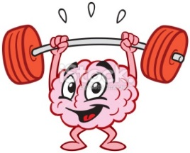
- col- A. not
- mal- ________ B. together
- in- ________, ________ C. wrong
- a/an- ________ D. in
- re- ________ E. against
- contra-________ F. again
Vocabulary Review
Directions: Write a sentence about the picture on the left using the word on the right.
intense
betray

Directions: Read the following excerpt from an interview with Marina Abramovic. Then answer the question that follows in ADE structure.

After my performance The Artist is Present (2010) at MoMA in New York, many scientists became interested in why so many people who sat across from me began to cry. I was incredibly moved by this experience also, and was very curious to know what happens in our brains when we spend time not talking, just looking at one another. So I have done a number of projects now with neuroscientists that include a re-staging of The Artist is Present with me and the audience wearing electrode caps to monitor what is happening. What they have found is that there is an incredible amount of activity that happens when you take the time to really look at another human being without any verbal exchange. The scientists are now using all of this data from these experiments to try to understand more about non-verbal communication between human beings. They have even developed a brain-powered car.

GO ON>

- How has art led to progress in science?
__________________________________________________________________________________
__________________________________________________________________________________
__________________________________________________________________________________
__________________________________________________________________________________
__________________________________________________________________________________
__________________________________________________________________________________
__________________________________________________________________________________
__________________________________________________________________________________
__________________________________________________________________________________
__________________________________________________________________________________
__________________________________________________________________________________
__________________________________________________________________________________

Answer to the Prompt  Details (Always 2)  Explanation | When answering questions that start with the word “How,” break the question up into two parts:  - What  - How

