NAME: _____________________ DATE: ______________________
SUBJECT: English Language Arts_ CLASS:______________________
Word Work
- What is the meaning of the prefix per-?
  - Through
  - Again
  - Together
  - Not
- How does the meaning of the suffix per- relate to the definition of perspiration?

GO ON>

- Based on the meaning of the prefix “per”, why is the midrib of the leaf described as percurrent?
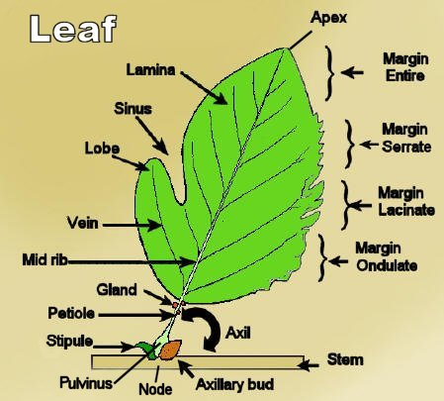

GO ON>

Vocabulary Review
Directions: Choose the sentence in which the word given is used correctly in grammar and meaning.
- resounding
  - I resoundingly heard a loud bang in the other room.
  - My daughter resounded the pots and pans.
  - There was a resounding bang in the other room.
  - The resounding pot fell to the floor.
- reputation
  - She always told her reputation to others because they didn’t know.
  - She had a reputation that followed her wherever she went.
  - I never told her reputation to anyone, so no one ever found out.
  - Her reputation secret made for good gossip that summer.

Esperanza Rising
Directions: Read pages 75 (scene mark) - 99 of Esperanza Rising. Then answer the questions that follow in complete sentences.

- What is Esperanza’s reaction to Mama speaking to Carmen?
________________________________________________________________
________________________________________________________________
- What does Carmen do that surprises Esperanza after she gets off the train?
________________________________________________________________
________________________________________________________________
- What does meeting Isabel tell Esperanza about Miguel?
________________________________________________________________
________________________________________________________________
- How is Marta’s family different from Esperanza’s family?
________________________________________________________________
________________________________________________________________

WRITE 1 STICKY NOTE RELATED TO ANY PART OF TONIGHT’S READING!

