NAME: _____________________ DATE: ______________________
SUBJECT: English Language Arts_ CLASS:______________________
Word Work

Directions: Review the table of common word parts. Then answer questions 1 and 2 based on the table.
com- | together
migra | move
electro | electricity
e- | out of
im- | inot

- Which word means to move together in a body or group from one country to another?
- commigrate
- emigrant
- electromigratory
- migratory
- Which word means to move under the influence of electrical currents?
  - commigrate
  - emigrant
  - electromigratory
  - migratory

- Read the sentence below from Charles Dickens’s novel David Copperfield.
“They will emigrate together, aunt.”
Based on the table of word parts on page 1, what is the meaning of the bolded word.
  - To leave a country to live elsewhere
  - To move with a group of people
  - To be carried by electrical currents
  - To move into a new country
Vocabulary Review
Directions: Every culture is different, so something that is tolerable in one culture may not be acceptable in another culture. Review the images below about ignorant mistakes to avoid when travelling to China. Then write one sentence about each image using the word ignorant.

- Never accept a compliment graciously.

Do deny a compliment is true.

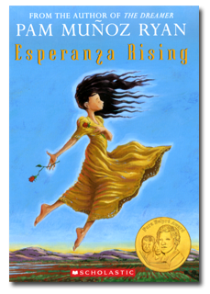
Esperanza Rising
Directions: Read pages 100-106 of Esperanza Rising. Then answer the questions that follow in complete sentences.

- What does Esperanza think of their cabin when she first sees it?
________________________________________________________________
________________________________________________________________
- Why don’t Esperanza and Mama live separately from Hortensia and Alfonso?
________________________________________________________________
________________________________________________________________
- What are the two choices Mama tells Esperanza they have now?
________________________________________________________________
________________________________________________________________
- How does Esperanza respond when Isabel asks her to tell about being rich?
________________________________________________________________
________________________________________________________________

WRITE 1 STICKY NOTE RELATED TO ANY PART OF TONIGHT’S READING!

