Name:___________________________Class____________________

6th Grade Physical Education HW 5 (Front & Back)

Review: Look at the food label and use it to answer the following questions:

- What is the ratio of grams of dietary fiber to sugars? .

- What is the ratio of grams of protein to total fat? .

- What is the ratio of grams of total carbohydrates to sugars? _____ .

- What is the ratio of grams of total carbohydrates to dietary fiber? .

- What is the ratio of grams of protein to dietary fiber? .

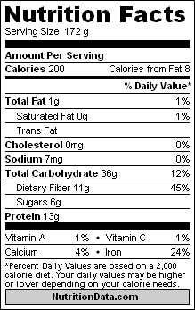

Name:___________________________Class____________________

6th Grade Physical Education HW 5 (Front & Back)

Review: Look at the food label and use it to answer the following questions:

- What is the ratio of grams of protein to dietary fiber? .

- What is the ratio of grams of total fat to protein? .

- What is the ratio of grams of total fat to dietary fiber? _____ .

- What is the ratio of grams of total carbohydrates to dietary fiber? .

- What is the ratio of grams of saturated fat to sugars? .

