The 5 Fitness Components

Study Guide

**Muscular Strength**

Memory Clues

* 1 muscle group used
* Short period of time
* Heavy Intensity

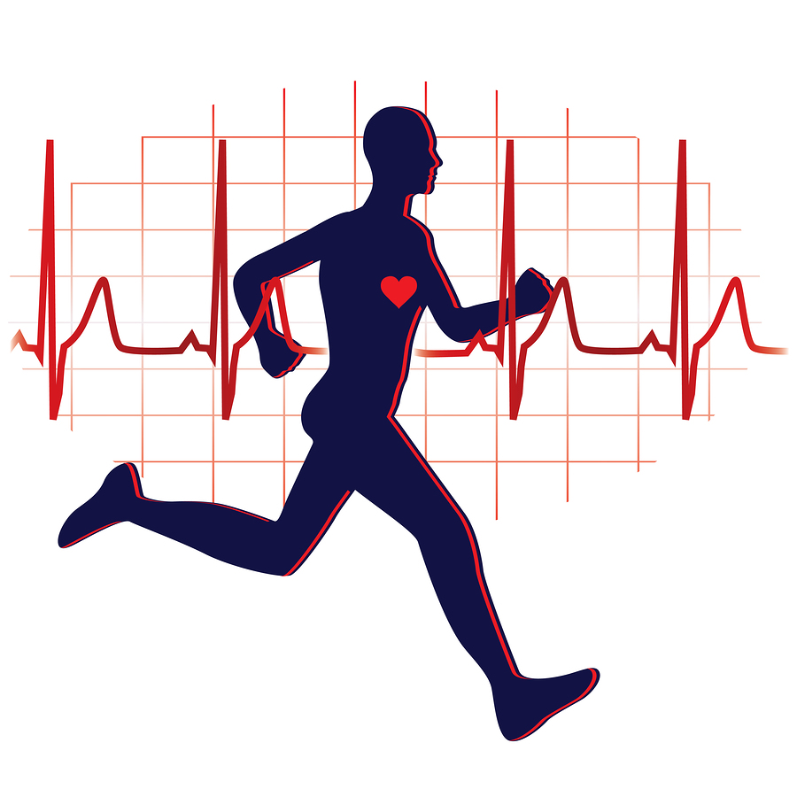



**Muscular Strength**

* Muscular = 1 muscle group
* Strength = maximum force

***Definition***

The ability of muscles to lift a heavy weight or exert a lot of force

one time.

**Cardiovascular Endurance**

Memory Clues

* Whole body used
* Oxygen to body & muscles
* Long time exercising (20 minutes minimum)
* Non-stop

**Cardiovascular Endurance**

* Cardio = Heart
* Vascular = Arteries w/ oxygen
* Endurance = the ability to keep going for a long period of time without getting tired.

***Definition***

The ability of the heart, lungs, blood vessels, and blood to work efficiently and to supply the body with oxygen.

The

5 Fitness

Components

Components

(parts of)

Fitness

* Cardiovascular Endurance
* Muscular Strength
* Muscular Endurance
* Flexibility
* Body Composition



**Muscular Endurance**

Memory Clues

* 1 muscle group used
* Long period of time
* Low to Moderate Intensity

**Muscular Endurance**

* Muscular = 1 muscle group
* Endurance = the ability to keep going for a long period of time without getting tired.

***Definition***

The ability to use muscles for a long period of time without tiring.

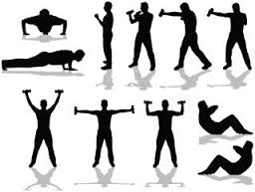

**Flexibility**

Memory Clues

* 1 muscle group used
* Stretch & bend
* Low Intensity

**Flexibility**

* Flex = stretch & bend
* ibility = the ability to do something

***Definition***

The ability to use your joints fully through a wide range of motion.

Improved with exercise & eating healthy

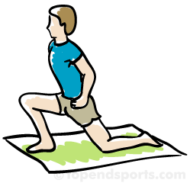

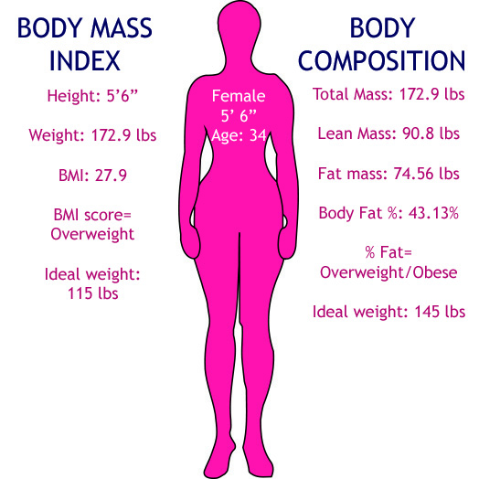

**Body Composition**

Memory Clues

* Make-up of the body
* Fat vs. bones, muscles, organs
* Measured by percentages %

**Body Composition**

* Body = All your organs and systems
* Composition = make-up, composed of

***Definition***

The percentage of your body’s tissues which are composed of fat versus tissues which are fat-free.

5 Fitness Components Memory Clue: **C**hocolate **M** & **M**’s **F**ight **B**ack

Cardiovascular Endurance, Muscular Strength, Muscular Endurance, Flexibility, Body Composition