Name: __________________________________________

ELA Homework

Mon. | Tues. | Wed. | Thurs. | Fri. | Sat. | Sun.
Nov. 30 | Dec. 1 | 2 | 3 | 4 | 5 | 6

Questions? Call or email Mr. Philipps!

Phone: 913-638-7855
Email: tom.philipps@tepcharter.org

Esperanza Reading Schedule:

Day | Pages
Monday | 100 – 106
Tuesday | 106 – 116
Wednesday | 116 – 120
Thursday | 121 – 129
Friday  Saturday  Sunday | 129 – 138

*Mr. Philipps will check this packet throughout the week. He will collect it for an effort grade first thing in class on Monday December 7*
Monday

Directions: Review the table of common word parts. Then answer questions 1 and 2 based on the table.

Word Part | Meaning
com- | together
migra | move
electro | electricity
e- | out of
im- | into

- Which word means “to move together in a body or group from one country to another”?

- commigrate

- emigrant

- electromigratory

- migratory

- Which word means “to move under the influence of electrical currents”?
  - commigrate
  - emigrant
  - electromigratory
  - migratory

3. Read the sentence below from Charles Dickens’s novel David Copperfield.
“They will emigrate together, aunt.”

Based on the table of word parts on page 1, what is the meaning of the bolded word?

  - to leave a country to live elsewhere

  - to move with a group of people

  - to be carried by electrical currents

  - to move into a new country

Vocabulary Review

Directions: Every culture is different, so something that is tolerable in one culture may not be acceptable in another culture. Review the images below about ignorant mistakes to avoid when travelling to China. Then write one sentence about each image using the word ignorant.

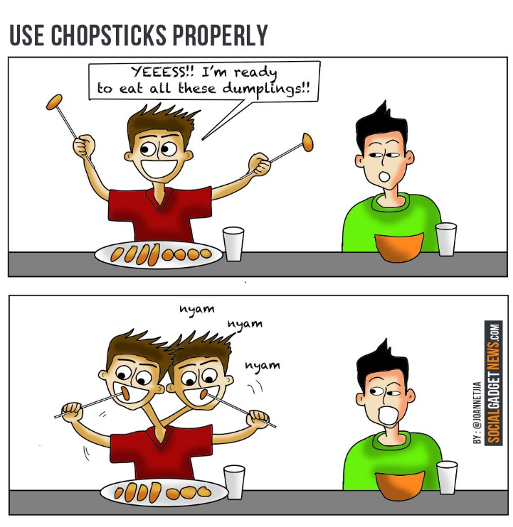
- Never accept a compliment graciously.
Do deny a compliment is true.

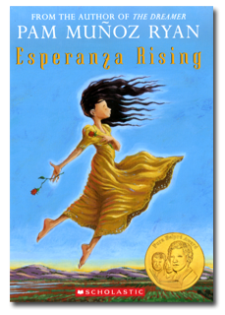
Esperanza Rising
Directions: Read pages 100 – 106 of Esperanza Rising. Then answer the questions that follow in complete sentences.

- What does Esperanza think of their cabin when she first sees it?

___________________________________________________________________
___________________________________________________________________
- Why don’t Esperanza and Mama live separately from Hortensia and Alfonso?

__________________________________________________________________
___________________________________________________________________

- What are the two choices Mama tells Esperanza they have now?

___________________________________________________________________
___________________________________________________________________
- How does Esperanza respond when Isabel asks her to tell about being rich?

___________________________________________________________________
___________________________________________________________________

WRITE 1 STICKY NOTE RELATED TO ANY PART OF TONIGHT’S READING!
Independent Reading Journal: Monday

- Read your independent reading book for 30 minutes.

- Complete the table:

Book Title

circle one:
fiction nonfiction/informational

Author

Pages Read

- Respond to the prompts:

- Paragraph 1: Why do you think the author(s) wrote this book? Be specific!

- Paragraph 2: What were you thinking about as you read? Be specific!

Paragraph 1: Why do you think the author(s) wrote this book? Be specific!

_________________________________________________________________
______________________________________________________________________________________________________________________________________________________________________________________________________________________________________________________________________________________________________________________________________________________________________________________________________

Paragraph 2: What were you thinking as you read? Be specific!

_________________________________________________________________
______________________________________________________________________________________________________________________________________________________________________________________________________________________________________________________________________________________________________________________________________________________________________________________________________

Strong Reading Response Checklist:

Paragraph 1 responds to Prompt 1.

Paragraph 2 responds to Prompt 2.

Response is neat and easy to read.

Tuesday

- The root migra means move. How does the meaning of the root migra relate to the definition of migrant?

Answer in the following format: “The root ‘migra’ means _______, which relates to “migrant” which means _______, because ________________.

- Read the sentence below.

The émigré searched the foreign city trying to find the employment office.

What is the meaning of émigré in the sentence?

- An émigré is the act of discovering something new and unfamiliar for the first time.

- An émigré is a city that someone is traveling to for the first time.

- An émigré is an official center of information for visitors.

- An émigré is someone who flees from his native land because of harsh conditions.
- Read the sentence below from Her Brilliant Career by Rachel Cooke about Judge Rose Heilbron who lived in England.

In April 1945 she was introduced to Nathaniel (Nat) Burstein, the sports-mad son of Polish émigrés and a local GP.

What context clue word helps the reader determine the meaning of émigré in the sentence?

- introduced

- sports-mad

- son

- polish

Vocabulary Review

Directions: Write a sentence about the graph using a form of the word given.

Hint: When using the word “prejudice” as an adjective, try using the preposition “against” after it. For example: The man was prejudiced against people of other religions.

- In a survey, English people were asked if they were prejudiced against people of other races, and this graph represents their responses.

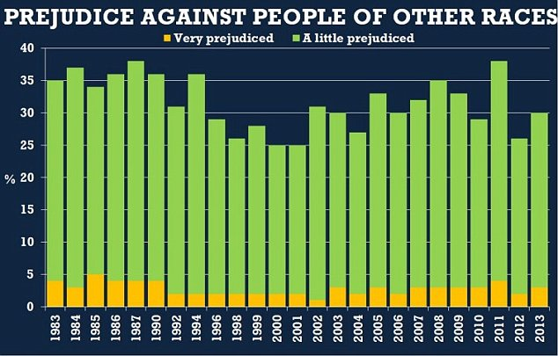

prejudice

Esperanza Rising
Directions: Read pages 106 – 116 of Esperanza Rising. Then answer the questions that
follow in complete sentences.

- What work will Esperanza be doing?

________________________________________________________________
________________________________________________________________
- What does Mama do to her hair?

________________________________________________________________
________________________________________________________________

- Where does Miguel go first to look for work?

________________________________________________________________
________________________________________________________________
- What mistake does Esperanza make when she washes the diapers?

________________________________________________________________
________________________________________________________________

REMEMBER: WRITE 1 POST-IT ABOUT ANY PART OF TONIGHT’S READING!
Independent Reading Journal: Tuesday

- Read your independent reading book for 30 minutes.
- Complete the table:

Book Title

circle one:
fiction nonfiction/informational

Author

Pages Read

- Respond to the prompts:

- Paragraph 1: What was the most important part of the text? Why?

- Paragraph 2: If you had to give this text another title, what would it be and why?

Paragraph 1: What was the most important part of the text? Why?

______________________________________________________________________________________________________________________________________________________________________________________________________________________________________________________________________________________________________________________________________________________________________________________________________
_________________________________________________________________

Paragraph 2: If you had to give this text another title, what would it be and why?

______________________________________________________________________________________________________________________________________________________________________________________________________________________________________________________________________________________________________________________________________________________________________________________________________
_________________________________________________________________

Strong Reading Response Checklist:

Paragraph 1 responds to Prompt 1.

Paragraph 2 responds to Prompt 2.

Response is neat and easy to read.

Wednesday

DO follow immigrate with “to”. | Example: The Syrians will immigrate to Greece.  NON-Example: The people immigrated from Syria.  *Note: To say moving from a country, use the word emigrate e.g. The people emigrated from Syria.
DON’T follow immigrate with “from”.

- How does the meaning of the root migra relate to the definition of immigrate?

Answer in the following format: “The root ‘migra’ means _______, which relates to ‘immigrate, which means _______, because _______________.

- Read the following sentence.
Further immigration of Pacific Islanders to Australia is now restricted, and the majority of those in the country in 1906 were deported by the middle of 1907.

If the word immigrate means to come to a country to live permanently, what does the word immigration mean?

  - a person who moves to a country to live permanently
  - a place where a person comes to live permanently
  - the process of moving to a country to live permanently
  - the decision to move to a country to live permanently
- Review the cartoon.

What is the relationship between the
words immigrant and migrant?

Vocabulary Review

Directions: Fill in the blanks with words from the Word Bank below.

Word Bank:

resounding resurrect reluctantly persistent perspiration

reputation resentfully pervasive migrate migrant immigrate

Tonight is the night before the big game, and I am imagining what tomorrow will be like. I can see myself running down the court, dribbling the ball, (4) _________________________________ dripping down my face. I can hear the (5) ____________________________ thump of the ball against the gym floor. No matter how many times the ball is taken by the other team, I will be (6) ___________________________ in constantly trying to reclaim the ball for my team. This relentless drive is what has given me the great
(7) ______________________ I have developed at school. Everyone knows I play hard. Though our team has lost the last five games, tomorrow we will win, and (8) __________________________________ our record.

Esperanza Rising
Directions: Read pages 116 – 120 of Esperanza Rising. Then answer the questions that
follow in complete sentences.

- What happened when Esperanza tried to sweep for the first time?

___________________________________________________________________
___________________________________________________________________

- What did Marta call Esperanza when she saw Esperanza sweeping?

__________________________________________________________________
___________________________________________________________________

- What was Miguel’s reaction to Esperanza being upset in the cabin?

___________________________________________________________________
___________________________________________________________________
- What does Esperanza ask Isabel for in exchange for stories of her life in Mexico?

___________________________________________________________________
___________________________________________________________________

REMEMBER: WRITE 1 POST-IT ABOUT ANY PART OF TONIGHT’S READING!
Independent Reading Journal: Wednesday

- Read your independent reading book for 30 minutes.

- Complete the table:

Book Title

circle one:
fiction nonfiction/informational

Author

Pages Read

- Respond to the prompts:

- Paragraph 1: What was the most entertaining part of the text? Why?

- Paragraph 2: Would you recommend this text to a friend? Why or why not?

Paragraph 1: What was the most entertaining part of the text? Why?

_________________________________________________________________
______________________________________________________________________________________________________________________________________________________________________________________________________________________________________________________________________________________________________________________________________________________________________________________________________

Paragraph 2: Would you recommend this text to a friend? Why or why not?

_________________________________________________________________
______________________________________________________________________________________________________________________________________________________________________________________________________________________________________________________________________________________________________________________________________________________________________________________________________

Strong Reading Response Checklist:

Paragraph 1 responds to Prompt 1.

Paragraph 2 responds to Prompt 2.

Response is neat and easy to read.

Thursday

- Which of the following statements is true about compound words?
  - If you know the meaning of the two words that are combined in a compound word, you do not need context to determine the meaning.

  - When two or more words are combined to have one meaning, they are called compound words.

  - A compound word usually comes before a noun and expresses a relationship to another word.

  - If a word joins two independent clauses or sentences to coordinate words in the same clause, it is a compound word.

- Based on your understanding of the words "work" and "horse", what does the term "workhorse" mean in the sentence below:

"While Jermaine was known for his natural talent and smarts, his twin brother Aaron was recognized as a workhorse."

  - Someone who is naturally talented.
  - Someone who comes from a successful family.
  - Someone who tries to copy someone else.
  - Someone who is hardworking.

- Which of the following compound words could be used to describe something that is pervasive?
  - widespread
  - itself
  - supersensitive
  - anymore

Vocabulary Review

Directions: Write a story using at least five of the words in the Word Bank below.

Word Bank:

resounding resurrect reluctantly persistent perspiration

reputation resentfully pervasive migrate migrant immigrate

________________________________________________________________________________________________________________________________________________________________________________________________________________________________________________________________________________________________________________________________________________________________________________________________________________________________________________________________________________________________________________________________________________________________________________________________________________________________________________________________________________________________________________________________________________________________________________________________________________________________________________________________________________________________________________________________________________________________________________________________________________________________________________________________________________
Need an idea of what to write about? Use an idea from the Idea Bank below.

Idea Bank: Justin Bieber TEP Tigers AMISTAD snowmen presents

Esperanza Rising
Directions: Read pages 121 – 129 of Esperanza Rising. Then answer the questions that
follow in complete sentences.

- What is the surprise that Alfonso and Miguel have for Esperanza and Mama?

___________________________________________________________________
___________________________________________________________________
- What does Esperanza learn to do by herself for the first time in preparation for the jamaica?

__________________________________________________________________
___________________________________________________________________

- How do the women get warm water for their baths?

___________________________________________________________________
___________________________________________________________________

- What makes Esperanza decide to come to the jamaica?

________________________________________________________________
________________________________________________________________
REMEMBER: WRITE 1 POST-IT ABOUT ANY PART OF TONIGHT’S READING!

Independent Reading Journal: Thursday

- Read your independent reading book for 30 minutes.

- Complete the table:

Book Title

circle one:
fiction nonfiction/informational

Author

Pages Read

- Respond to the prompts:

- Paragraph 1: Did anything in this section of the text come as a surprise? Why?

- Paragraph 2: What emotions did the text evoke as you read (i.e. how did you feel while reading)? Did this text make you laugh? Cry? Cringe? Smile? Cheer? Explain.

Paragraph 1: Did anything in this section of the text come as a surprise? Why?

_________________________________________________________________
______________________________________________________________________________________________________________________________________________________________________________________________________________________________________________________________________________________________________________________________________________________________________________________________________

Paragraph 2: What emotions did the text evoke as you read (i.e. how did you feel while reading)? Did this text make you laugh? Cry? Cringe? Smile? Cheer? Explain.

_________________________________________________________________
______________________________________________________________________________________________________________________________________________________________________________________________________________________________________________________________________________________________________________________________________________________________________________________________________

Strong Reading Response Checklist:

Paragraph 1 responds to Prompt 1.

Paragraph 2 responds to Prompt 2.

Response is neat and easy to read.

Friday

- The prefix de- means down, off, away and indicates separation. From what word does someone who is desperate feel separated?
- hope
- sadness
- people
- fear

Directions: Review the table of common word parts. Then answer questions 2 and 3 based on the table.

Word Part | Meaning
de- | down, off, away
act | drive, do
able | capable
but | strike

- Which word means to stop something from working by disconnecting or destroying something?
- deactivate
- debuting
- deaccelerate
- determine

- Which word means to make weak?
- debug
- debilitate
- declassify
- deceive
Vocabulary Review

Directions: Write a sentence about the image on the left using the word given.

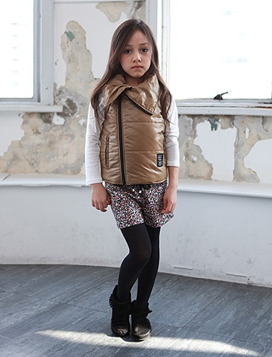 | resentfully
 | reluctantly

Esperanza Rising
Directions: Read pages 129 – 138 of Esperanza Rising. Then answer the questions that
follow in complete sentences.

- What does Isabel want to bring home from the fiesta?

___________________________________________________________________
___________________________________________________________________
- On pages 131–133, Marta is using kittens as a metaphor for the farmers. According to Marta, how are the farmers like the kittens?

__________________________________________________________________
___________________________________________________________________
- What is Marta encouraging others to do?

___________________________________________________________________
___________________________________________________________________
- What does Mama miss most from home?

___________________________________________________________________
___________________________________________________________________

REMEMBER: WRITE 1 POST-IT ABOUT ANY PART OF TONIGHT’S READING!
Independent Reading Journal: Friday

- Read your independent reading book for 30 minutes.

- Complete the table:

Book Title

circle one:
fiction nonfiction/informational

Author

Pages Read

- Respond to the prompts:

- Paragraph 1: What is a theme of this text? How do you know?

- Paragraph 2: Summarize this section of the text in 3 – 4 sentences.

Paragraph 1: What is a theme of this text? How do you know?

_________________________________________________________________
______________________________________________________________________________________________________________________________________________________________________________________________________________________________________________________________________________________________________________________________________________________________________________________________________

Paragraph 2: Summarize this section of the text in 3 – 4 sentences?

_________________________________________________________________
______________________________________________________________________________________________________________________________________________________________________________________________________________________________________________________________________________________________________________________________________________________________________________________________________

Strong Reading Response Checklist:

Paragraph 1 responds to Prompt 1.

Paragraph 2 responds to Prompt 2.

Response is neat and easy to read.

Independent Reading Journal: Saturday

- Read your independent reading book for 30 minutes.

- Complete the table:

Book Title

circle one:
fiction nonfiction/informational

Author

Pages Read

- Respond to the prompts:

- Paragraph 1: Does this text seem similar to any other you have read (or watched)? In what ways are these two texts similar? Explain.

- Paragraph 2: Would you like to read other texts by this author? Why or why not?

Paragraph 1: Does this text seem similar to any other you have read (or watched)? In what ways are these two texts similar? Explain.

_________________________________________________________________
______________________________________________________________________________________________________________________________________________________________________________________________________________________________________________________________________________________________________________________________________________________________________________________________________

Paragraph 2: Would you like to read other texts by this author? Why or why not?

_________________________________________________________________
______________________________________________________________________________________________________________________________________________________________________________________________________________________________________________________________________________________________________________________________________________________________________________________________________

Strong Reading Response Checklist:

Paragraph 1 responds to Prompt 1.

Paragraph 2 responds to Prompt 2.

Response is neat and easy to read.

Independent Reading Journal: Sunday

- Read your independent reading book for 30 minutes.

- Complete the table:

Book Title

circle one:
fiction nonfiction/informational

Author

Pages Read

- Respond to the prompts:

- Paragraph 1: If you had the chance to travel to the place (or places) your text is set, would you? Explain.

- Paragraph 2: Why did the author(s) write this text? Why do you think this?

Paragraph 1: If you had the chance to travel to the place (or places) your text is set, would you? Explain.

_________________________________________________________________
______________________________________________________________________________________________________________________________________________________________________________________________________________________________________________________________________________________________________________________________________________________________________________________________________

Paragraph 2: Why did the author(s) write this text? Why do you think this?

_________________________________________________________________
______________________________________________________________________________________________________________________________________________________________________________________________________________________________________________________________________________________________________________________________________________________________________________________________________

Strong Reading Response Checklist:

Paragraph 1 responds to Prompt 1.

Paragraph 2 responds to Prompt 2.

Response is neat and easy to read.

